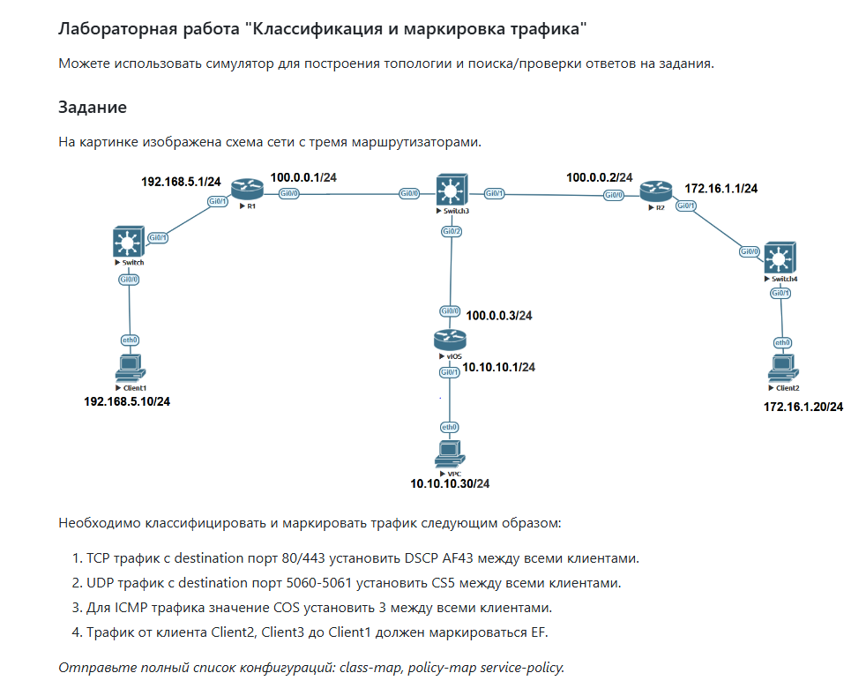

Решение:
ACL (классификация):
! 1. TCP dst 80/443
ip access-list extended TCP_WEB
permit tcp any any eq 80
permit tcp any any eq 443

! 2. UDP dst 5060-5061
ip access-list extended UDP_SIP
permit udp any any range 5060 5061

! 3. ICMP
ip access-list extended ICMP_TRAFFIC
permit icmp any any

! 4. Traffic Client2/Client3 → Client1
ip access-list extended TO_CLIENT1
permit ip host 172.16.1.20 host 192.168.5.10
permit ip host 10.10.30.20 host 192.168.5.10

Class-map (match)
class-map match-any CLASS_TCP_WEB
match access-group name TCP_WEB

class-map match-any CLASS_UDP_SIP
match access-group name UDP_SIP

class-map match-any CLASS_ICMP
match access-group name ICMP_TRAFFIC

class-map match-any CLASS_TO_CLIENT1
match access-group name TO_CLIENT1

Policy-map (маркировка)
policy-map MARKING_POLICY

class CLASS_TCP_WEB
set dscp af43

class CLASS_UDP_SIP
set cos 5

class CLASS_ICMP
set cos 3

class CLASS_TO_CLIENT1
set dscp ef

class class-default
set dscp default

Применение (service-policy):
Маркировка делается на входе интерфейсов, куда приходит трафик от клиентов.
- На R1 (трафик от Client1):
interface GigabitEthernet0/1
description Link to Client1
service-policy input MARKING_POLICY

- На R2 (трафик от Client2):
interface GigabitEthernet0/1
description Link to Client2
service-policy input MARKING_POLICY

- На R3 / vIOS / где подключён Client3:
interface GigabitEthernet0/1
description Link to Client3
service-policy input MARKING_POLICY

